

DEPARTMENT: COMPUTING AND INFORMATICS.
UNIT: SCIENTIFIC COMPUTING.
UNIT CODE: 2118.
YEAR, SEM: 2026, SEPT/DEC.

PRESENTED BY:
GROUP 18.
NAME | REG NO.
1. Natasha Wanjiru | BSCCS/2024/53895
2. Alice Nzomo | BSCCS/2024/73556
3. Scarlet Patience | BSCCS/2024/54567
4. Maureen Wanjiku | BSCCS/2024/73963
5. Morris Maina | BSCCS/2024/55176
6. Juakim Njuguna | BSCCS/2024/54733
7. Brian Japan | BSCCS/2024/74678
8. Levi Omare | BSCCS/2024/56230
9. Gideon Chebet | BSCCS/2024/73487
10. Caleb Mwangi | BSCCS/2024/74201

Table of Contents.
Task 2: NumPy Arrays and Numerical Computation. 3
Task 3: Mathematical Functions and Vectorization. 4
Task 4: Floating-Point Arithmetic and Numerical Errors. 5
Task 5: Matrix Algebra and Matrix Operations. 5
Task 6: Solution of Systems of Linear Equations. 6
Task 7: Gaussian Elimination and LU Decomposition. 7
Task 8: Iterative Methods for Linear Systems. 7
Task 9: Eigenvalues and Eigenvectors. 8
Task 10: Root Finding: Bisection and Fixed-Point Methods. 9
Task 11: Root Finding: Newton-Raphson and Secant Methods. 10
Task 12: Polynomial and Nonlinear Equation Solving. 10
Task 13: Interpolation. 11
Task 14: Curve Fitting and Approximation. 12
Task 15: Numerical Differentiation. 13
Task 16: Numerical Integration. 13
Task 17: Ordinary Differential Equations: Euler Method. 14
Task 18: Numerical Solution of ODEs Using SciPy. 15
Task 19: Numerical Optimization. 15
Task 20: Random Numbers and Monte Carlo Methods. 16

Table Of Figures. 2
Modified program (code/Task_02_numpy_arrays_modified.py): 4
Modified program (code/Task_03_vectorization_modified.py): 5
Modified program (code/Task_04_numerical_errors_modified.py): 5
Modified program (code/Task_05_matrix_algebra_modified.py): 6
Modified program (code/Task_06_linear_systems_modified.py): 7
Modified program (code/Task_07_gaussian_lu_modified.py): 8
Modified program (code/Task_08_iterative_linear_modified.py): 8
Modified program (code/Task_09_eigenvalues_modified.py): 9
Modified program (code/Task_10_root_finding_modified.py): 10
Modified program (code/Task_11_irr_modified.py): 10
Modified program (code/Task_12_nonlinear_modified.py): 11
Modified program (code/Task_13_interpolation_modified.py): 12
Modified program (code/Task_14_curve_fitting_modified.py): 13
Modified program (code/Task_15_differentiation_modified.py): 13
Modified program (code/Task_16_integration_modified.py): 14
Modified program (code/Task_17_euler_modified.py): 15
Modified program (code/Task_18_scipy_ode_modified.py): 15
Modified program (code/Task_19_optimization_modified.py): 16
Modified program (code/Task_20_monte_carlo_modified.py): 17

Task 2: NumPy Arrays and Numerical Computation.
B. Inputs and operation: Input is an array of 24 hourly temperatures in °C. The operations are mean, min, max, and the vectorized conversion F = 1.8C + 32 applied to every element at once.
D. Output: Mean 23.12 °C, minimum 17.50 °C, maximum 29.40 °C. The first six Fahrenheit values are 65.30, 64.40, 64.04, 63.50, 64.22, 66.20. So the day is coolest in the early morning (about 17.5 °C) and warmest around midday (29.4 °C), and the mean sits between them.
C. Parameter change: We added 3 °C to every reading (temperatures_c = temperatures_c + 3). Mean became 26.12, min 20.5 and max 32.4. Every statistic shifted by exactly 3 °C, and the Fahrenheit values shift by 3 × 1.8 = 5.4 °F. Adding a constant moves the mean, min and max by that constant but does not change the spread.
E. Modified case (greenhouse sensor in Nairobi highlands): 24 hourly readings from one IoT sensor, no missing values (invented data). We added a count of hours above 25 °C and the hottest hour.
Modified program (code/Task_02_numpy_arrays_modified.py):
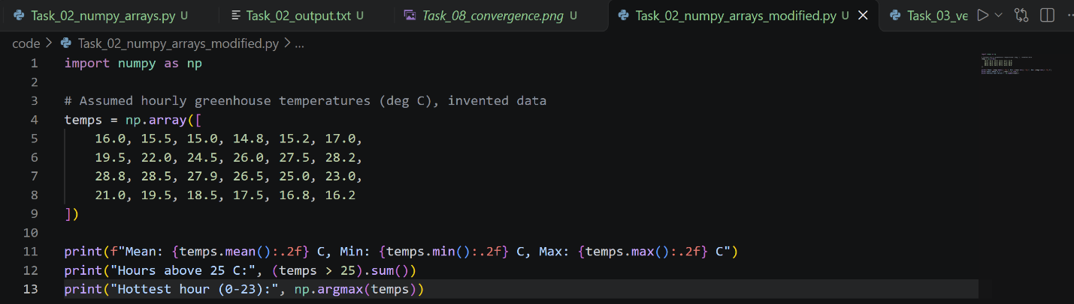
Output and interpretation: Mean 21.27 °C, min 14.80 °C, max 28.80 °C, 7 hours above 25 °C, hottest hour 12. The greenhouse is above 25 °C for 7 hours, so the farmer should plan ventilation or shading around noon.

Task 3: Mathematical Functions and Vectorization.
B. Inputs and operation: Input is 1,000,000 random latencies between 5 and 250 ms. The operation is convert ms to seconds (divide by 1000) and square, done once with a Python loop and once with a vectorized expression.
D. Output: First five squared values (s²): 0.0379, 0.0127, 0.0464, 0.0309, 0.0008. The loop took 0.1105 s and the vectorized version 0.0019 s, about 57 times faster. Both give identical answers; vectorization runs the loop in compiled C code instead of interpreted Python.
C. Parameter change: We changed 1_000_000 to 100_000 and 5_000_000. The speed-up was about 117× and 62×. The time grows with data size for both methods, but the vectorized one stays much faster at every size. Timings vary between runs and computers.
E. Modified case (internet bandwidth): 1,000 speed tests uniformly between 10 and 100 Mbps, with 1 byte = 8 bits. We convert to MB/s and compute the root-mean-square (RMS).
Modified program (code/Task_03_vectorization_modified.py):
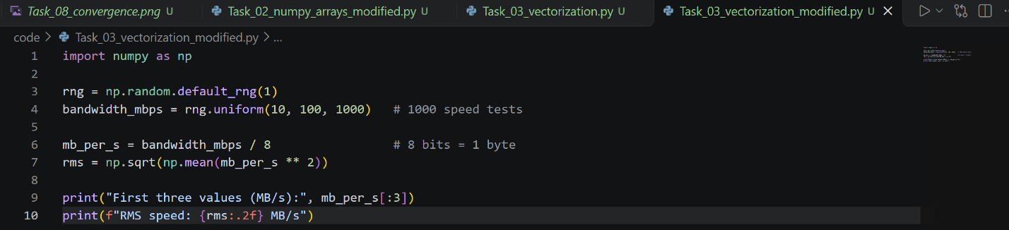
Output and interpretation: First values 7.01, 11.94, 2.87 MB/s; RMS 7.64 MB/s. A typical user downloads about 7.6 MB/s. RMS gives more weight to the fast connections than a plain mean does.

Task 4: Floating-Point Arithmetic and Numerical Errors.
B. Inputs and operation: Inputs are 0.1 + 0.2 vs 0.3, √2 vs 1.414, and small x values. Operations are exact comparison, np.isclose, absolute error |true − approx|, relative error, and two algebraically equal formulas for (√(1+x) − 1)/x.
D. Output: 0.1 + 0.2 = 0.30000000000000004, so == gives False but np.isclose gives True. Absolute error of 1.414 is 0.00021356 and relative error 0.0151%. For the unstable formula, at x = 1e-4 both formulas give about 0.49998750, at 1e-8 the direct formula gives 0.499999996961 against the true 0.499999998750, and at 1e-12 it gives 0.500044450291 while the stable one gives 0.500000000000. The direct formula subtracts two nearly equal numbers (catastrophic cancellation), so it loses digits. At x = 1e-15 the direct result is 0.444, wrong by over 11%.
C. Parameter change: Setting approx_value = 1.41421 reduced the absolute error from 2.1e-4 to 3.6e-6. More digits gives a smaller truncation error.
E. Modified case (banking accumulation): A system adds 0.1 to a balance one million times; the true total is 100,000. We also test float32.
Modified program (code/Task_04_numerical_errors_modified.py):
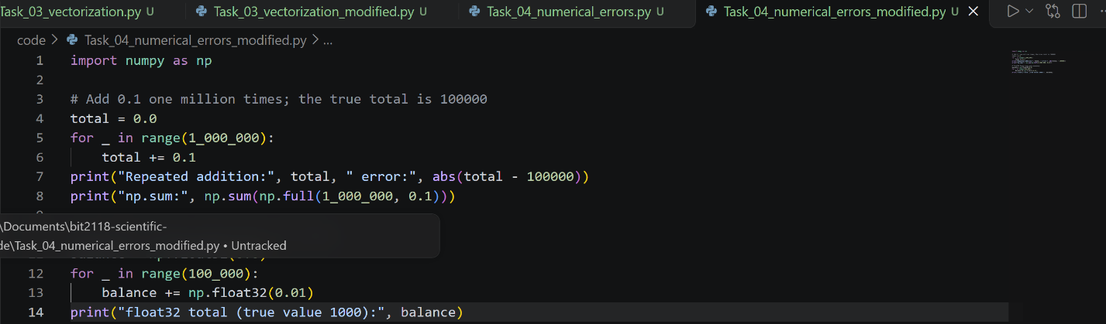
Output and interpretation: Repeated addition gives 100000.00000133 (error 1.3e-6), np.sum gives 100000.00000000003, and float32 gives about 1000.665 instead of 1000. Errors accumulate with repeated operations. Banks use integer cents or the decimal module for money, never plain floats.

Task 5: Matrix Algebra and Matrix Operations.
B. Inputs and operation: Inputs are the four corners of a unit square, a 45° rotation matrix and a scaling matrix (2 in x, 1.5 in y). The operation is matrix multiplication rotation @ scale and then points @ T.T, plus the determinant.
D. Output: The combined matrix is [[1.4142, −1.0607], [1.4142, 1.0607]]. Transformed points: (0,0), (1.4142, 1.4142), (0.3536, 2.4749), (−1.0607, 1.0607). The determinant is 3.0, which equals 2 × 1.5, so the area of the square is multiplied by 3 (rotation does not change area, scaling does).
C. Parameter change: With np.deg2rad(90) the corners become (0,0), (0,2), (−1.5,2), (−1.5,0), a rectangle turned a quarter turn. The determinant stays 3. With scale 1 and 1 the determinant is 1, meaning a pure rotation keeps area.
E. Modified case (robot arm waypoints): A 2-D path with corners (0,0), (2,0), (2,1), (0,1) is rotated 30° and moved by (3, 2). Translation needs 3×3 homogeneous matrices.
Modified program (code/Task_05_matrix_algebra_modified.py):
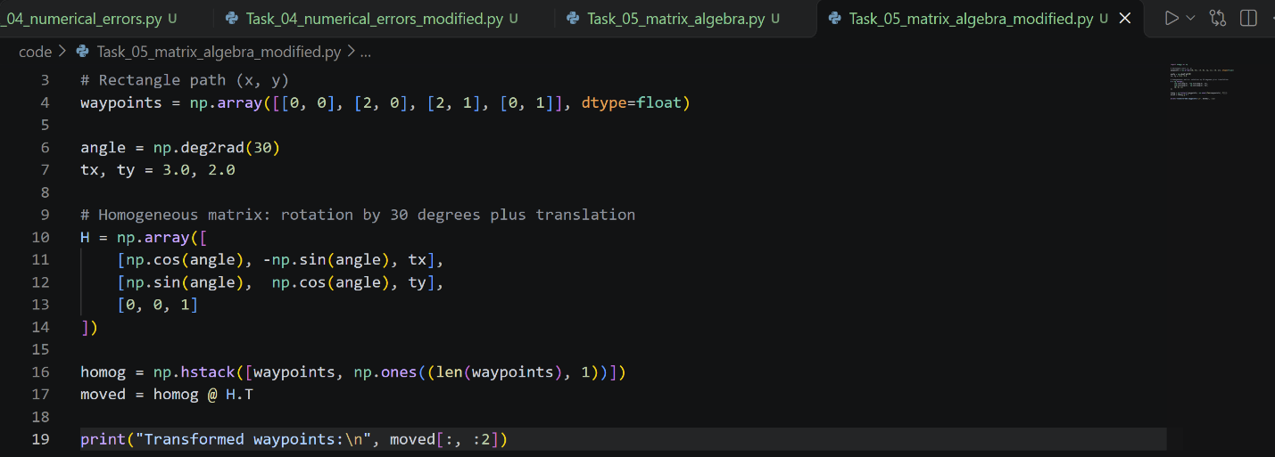

Output and interpretation: (3, 2), (4.732, 3.000), (4.232, 3.866), (2.5, 2.866). The whole rectangular path is rotated and shifted without changing its shape or size, so one matrix moves all waypoints consistently.

Task 6: Solution of Systems of Linear Equations.
B. Inputs and operation: A = [[4,2],[8,12]] (CPU and memory per server) and b = [20, 72] (totals). np.linalg.solve(A, b) finds x so that Ax = b; the residual b − Ax checks it.
D. Output: 3 Type A servers and 4 Type B servers. Check: 4(3) + 2(4) = 20 CPU and 8(3) + 12(4) = 72 GB. The residual norm is essentially 0, so the answer is accurate.
C. Parameter change: With b = np.array([30.0, 100.0]) the answer becomes 5 and 5. Bigger totals mean more servers; the system still has one unique solution because A is invertible.
E. Modified case (two-loop circuit): R1 = 10 Ω, R2 = 20 Ω, R3 = 30 Ω, V1 = 12 V, V2 = 6 V. Mesh equations: 30·I1 − 20·I2 = 12 and −20·I1 + 50·I2 = −6.
Modified program (code/Task_06_linear_systems_modified.py):
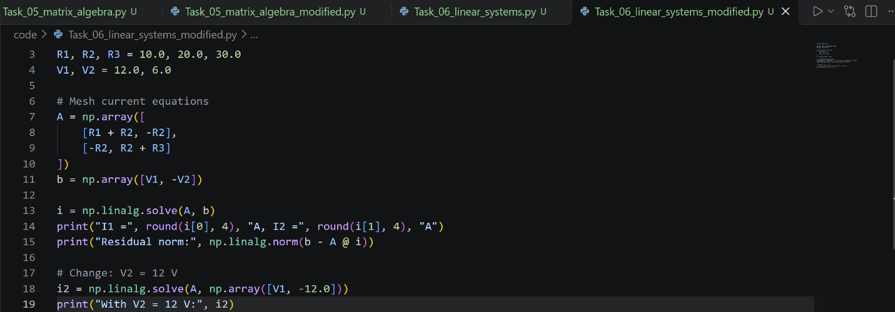
Output and interpretation: I1 = 0.4364 A, I2 = 0.0545 A. Both currents are positive, so they flow in the assumed directions. With V2 = 12 V, I2 becomes −0.1091 A; the negative sign means that current flows opposite to our assumed direction.

Task 7: Gaussian Elimination and LU Decomposition.
B. Inputs and operation: A is a 3×3 coefficient matrix used with three different measurement vectors b. lu_factor splits A = LU once, then lu_solve reuses it for each b.
D. Output: b = [15,10,10] gives x = [5, 5, 5]; b = [16,11,9] gives [5.317, 5.268, 4.756]; b = [14,12,11] gives [4.902, 5.610, 5.537]. Residual norms are about 1e-15, so the solutions are accurate to machine precision. Factoring once avoids repeating the expensive elimination.
C. Parameter change: Adding np.array([30.0, 0.0, 0.0]) to measurement_sets gives x = [8.049, 2.195, 0.732]. The first unknown is largest because the load is applied to the first equation and its effect decreases along the chain.
E. Modified case (four-node structure under load): A 4×4 tridiagonal stiffness-like matrix with 3 on the diagonal and −1 beside it. The same matrix is used for several load cases.
Modified program (code/Task_07_gaussian_lu_modified.py):
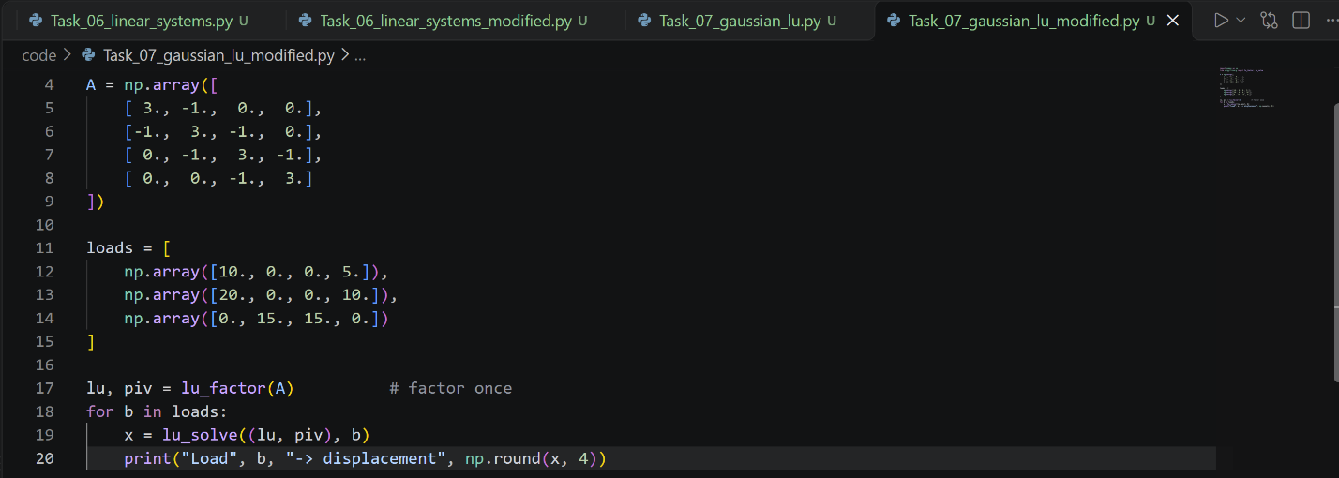
Output and interpretation: Loads [10,0,0,5] give [3.909, 1.727, 1.273, 2.091]; doubling to [20,0,0,10] gives exactly double; [0,15,15,0] gives [3, 9, 9, 3]. The system is linear, so double the load means double the displacement, and the symmetric load gives a symmetric answer.

Task 8: Iterative Methods for Linear Systems.
B. Inputs and operation: A is a 5×5 tridiagonal matrix (2 on the diagonal, −1 beside it) and b = [100,0,0,0,20] for boundaries of 100 °C and 20 °C. Jacobi uses only old values; Gauss-Seidel uses updated values immediately. Stopping tolerance is 1e-8.
D. Output: Both reach T = [86.67, 73.33, 60.00, 46.67, 33.33], the same as the direct solver. Jacobi needed 150 iterations and Gauss-Seidel 75. On the graph, the maximum change falls as a straight line on the log scale, and the Gauss-Seidel line falls twice as steeply. The temperatures drop linearly from the hot side to the cold side, as expected for heat conduction in steady state.
C. Parameter change: A looser tolerance of 1e-3 needed only 70 (Jacobi) and 35 (Gauss-Seidel) iterations. With b = np.array([200., 0., 0., 0., 20.]) (and max_iter=5000) the temperatures become [170, 140, 110, 80, 50] and iterations rise slightly to 154 and 77.
E. Modified case (metal rod with 7 interior points): Ends held at 80 °C and 30 °C, no heat source, steady state.
Modified program (code/Task_08_iterative_linear_modified.py):
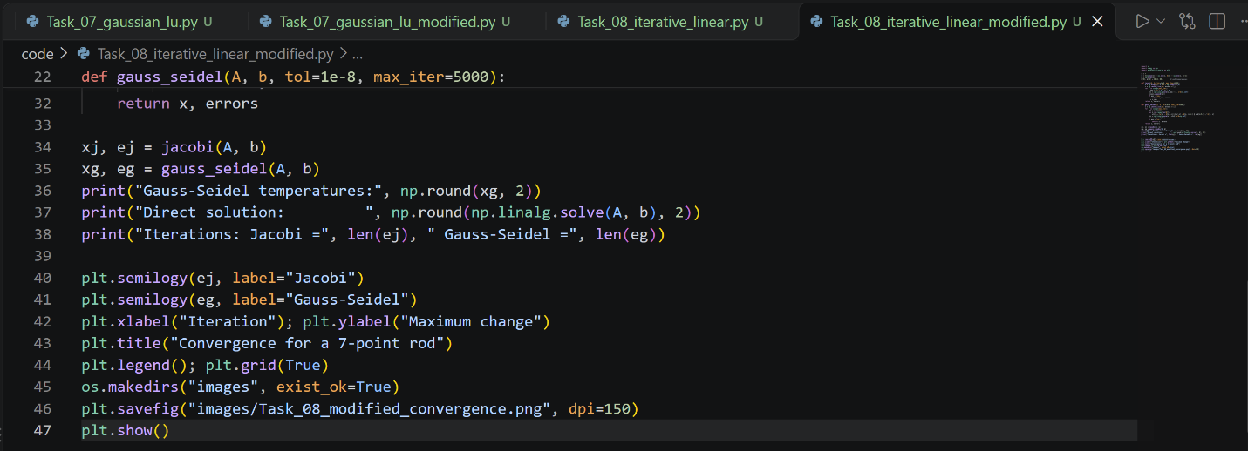
Output and interpretation: T = 73.75, 67.50, 61.25, 55.00, 48.75, 42.50, 36.25. Jacobi took 263 iterations and Gauss-Seidel 132. More grid points means slower convergence, and Gauss-Seidel stays about twice as fast. The temperature decreases by 6.25 °C per point.

Task 9: Eigenvalues and Eigenvectors.
B. Inputs and operation: The 4×4 adjacency matrix of a network (A–B, A–C, B–C, B–D, C–D). np.linalg.eig finds λ and v with Av = λv. The dominant eigenvector, normalized, gives node importance.
D. Output: Dominant eigenvalue 2.5616. Importance: A 0.2192, B 0.2808, C 0.2808, D 0.2192. B and C are most influential because each connects to three nodes. The verification error is near zero, so Av = λv holds.
C. Parameter change: Adding a link A–D (A[0,3] = A[3,0] = 1) makes every node connected to every other. The eigenvalue becomes 3.0 and all scores equal 0.25, since the network is now perfectly symmetric.
E. Modified case (5-person friend network): Links A–B, A–C, B–C, C–D, D–E, undirected.
Modified program (code/Task_09_eigenvalues_modified.py):
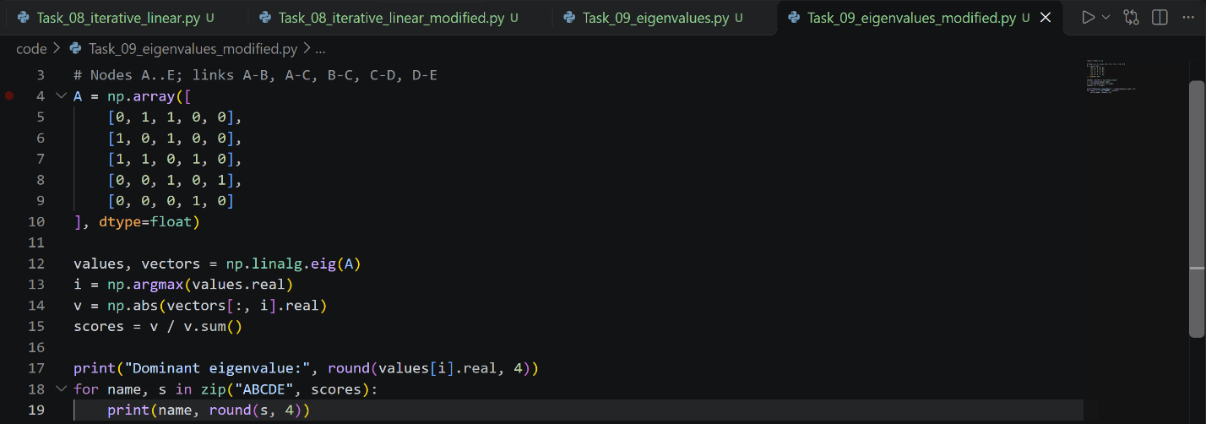
Output and interpretation: λ = 2.2143; A 0.2373, B 0.2373, C 0.2881, D 0.1635, E 0.0738. C is the most central person because it bridges the triangle and the chain. E is the least central because it has only one link, to D.

Task 10: Root Finding: Bisection and Fixed-Point Methods.
B. Inputs and operation: f(T) = T − 25 − 10e^(−T/20), bracket [20, 40], tolerance 1e-10. Bisection halves the interval; fixed-point uses T = 25 + 10e^(−T/20) starting at 30.
D. Output: Both methods give T = 27.525211 °C. Bisection used 38 halvings and fixed-point only 13 iterations. On the graph, the curve crosses zero at about 27.5 °C, where heat gain equals heat loss.
C. Parameter change: Changing 10 to 20 in the exponential term (and the bracket to [20, 60]) moves the equilibrium to 29.56 °C, since more heat gain means a higher balance temperature. Loosening the tolerance to 1e-3 gives 27.52502 in 15 steps, so we lose accuracy in the 5th decimal but save steps.
E. Modified case (break-even production): profit(q) = 30q − 0.01q² − 2000 (selling margin 30 per unit, rising cost, fixed cost 2000). Break-even is where profit = 0.
Modified program (code/Task_10_root_finding_modified.py):
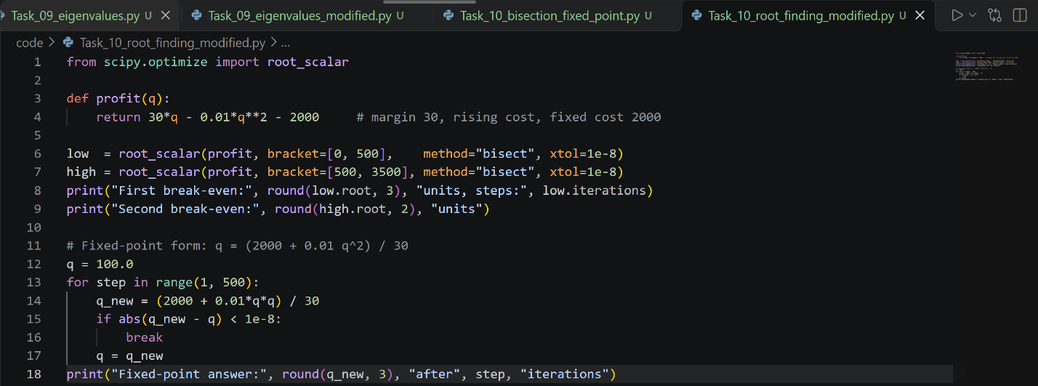
Output and interpretation: Bisection on [0, 500] gives q = 68.218 in 36 steps; fixed-point gives the same in 9 steps; the second root is q = 2931.78. The company needs at least 69 units to make a profit. Beyond about 2932 units the quadratic cost wipes out the profit again.

Task 11: Root Finding: Newton-Raphson and Secant Methods.
B. Inputs and operation: Cash flows [−10000, 3000, 3500, 4000, 2500]. We solve NPV(r) = 0 to find the internal rate of return (IRR), using Newton with the derivative and secant without it.
D. Output: Both give IRR = 11.542461%. Newton took 4 iterations and secant 7. NPV at the answer is about 0. In words, the investment earns an 11.54% yearly return; if our required return is below that, the project is worthwhile (NPV at 10% is +332.63).
C. Parameter change: With cash_flows = [-10000, 2000, 2500, 3000, 2500], which add up to exactly the investment of 10,000, the IRR becomes 0%. We just get our money back with no growth.
E. Modified case (business loan or project): Invest 50,000 and receive 15,000 at the end of each of 5 years.
Modified program (code/Task_11_irr_modified.py):
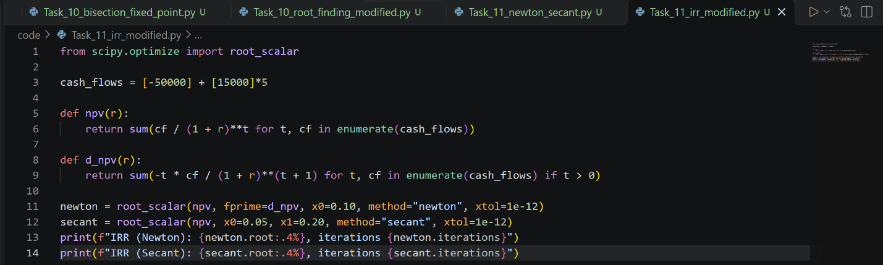
Output and interpretation: IRR = 15.2382% (Newton 5 iterations, secant 6). If the bank loan costs less than 15.24% per year, the project can repay it. If the loan rate is higher, the project loses money.

Task 12: Polynomial and Nonlinear Equation Solving.
B. Inputs and operation: Circle x² + y² = 4 and parabola y = x² − 1. scipy.optimize.root finds (x, y) making both residuals zero, starting from initial guesses.
D. Output: From guesses (1,1) and (−1,1) we get (1.5175, 1.3028) and (−1.5175, 1.3028), residuals about 1e-13, converged True. The guess (1,−1) failed (converged False, residuals −0.24 and −0.94). Algebraically, substituting gives y² + y − 3 = 0, so y = 1.3028 or y = −2.3028, and y = −2.3028 would need x² = −1.3, which is impossible. So there are only two real intersections and the solver cannot find a third.
C. Parameter change: Changing the 4 to 9 (radius 3) with guess [2.0, 3.0] gives one intersection at (1.8364, 2.3723). A larger circle meets the parabola higher up. The result depends on the starting guess, so we should always check the success flag and the residuals.
E. Modified case (overlapping cell-tower coverage): Tower 1 at (0,0) with range 5 km, tower 2 at (6,0) with range 4 km.
Modified program (code/Task_12_nonlinear_modified.py):
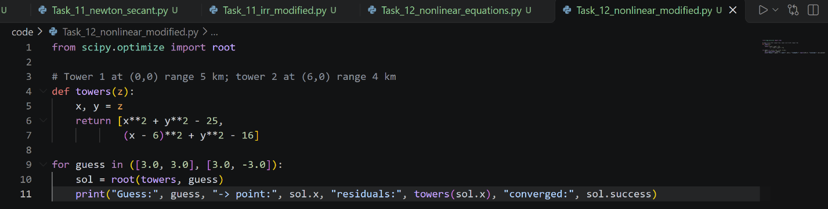
Output and interpretation: Points (3.75, 3.3072) and (3.75, −3.3072), both with zero residual. These are the two places where a phone is exactly at the edge of both towers. The overlap region between them is where a phone can hand over between towers.

Task 13: Interpolation.
B. Inputs and operation: Hourly temperatures from 08:00 to 14:00. interp1d (linear) and CubicSpline estimate values between the measurements.
D. Output: At 10:30 the linear estimate is 23.25 °C and the cubic estimate 23.36 °C. On the graph both curves pass through every measured point; the linear one is made of straight segments with corners, while the spline is smooth. Near 08:30 they give 19.00 and 18.81, and near 13:30 25.25 and 25.41, so they differ most where the curvature is highest.
C. Parameter change: We removed the 11:00 value (true value 24 °C) from the data and predicted it. Linear gave 23.75 (error 0.25) and cubic gave 24.11 (error 0.11). The spline did better because the temperature curve is smooth, not straight. (You can also set target_time = 8.5 to compare the estimates near the start.)
E. Modified case (cumulative rainfall): Gauge readings every 3 hours (0 to 18 h) of 0, 2.0, 5.5, 9.0, 10.5, 11.0, 11.2 mm.
Modified program (code/Task_13_interpolation_modified.py):
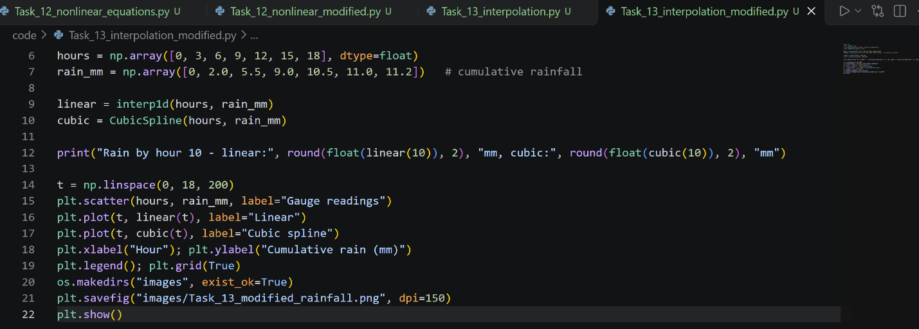
Output and interpretation: At hour 10 linear gives 9.50 mm and cubic 9.71 mm. The cubic estimate is higher because it follows the curve that is flattening out. Either way, about 9.5–9.7 mm of rain had fallen by 10:00.

Task 14: Curve Fitting and Approximation.
B. Inputs and operation: Users 50–350 and response times 82–305 ms. curve_fit finds a, b, c of y = ax² + bx + c by minimizing the sum of squared residuals. RMSE measures the fit.
D. Output: y = 0.0022x² − 0.1345x + 85.00, RMSE 1.55 ms, predicted 377.86 ms at 400 users. The fitted curve passes very close to all points and bends upward, meaning response time grows faster as the load grows.
C. Parameter change: A straight line (np.polyfit(users, response_ms, 1), y = 0.7321x + 20) has RMSE 18.83 ms and predicts only 312.86 ms at 400 users, so it underestimates the slowdown. An exponential model fits about as well as the quadratic (RMSE 1.43) but predicts 400.36 ms at 400 users. Extrapolating the quadratic to 600 users gives 784 ms, so models far outside the data should not be trusted too much.
E. Modified case (phone battery drain): Battery % measured at 0, 1, 2, 3, 4, 5, 6, 8 hours: 100, 91, 83, 76, 69, 63, 58, 48. Model y = a·e^(−kt).
Modified program (code/Task_14_curve_fitting_modified.py):
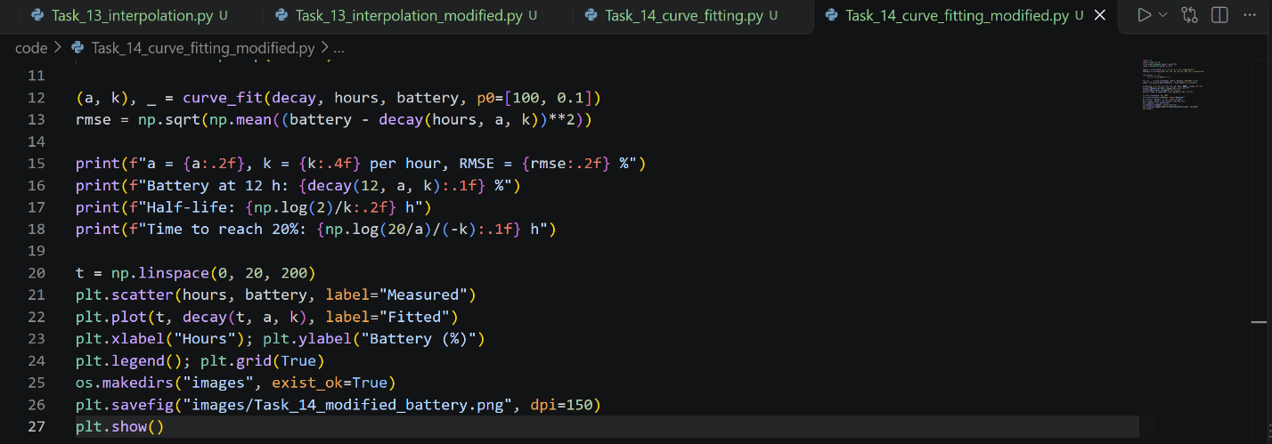
Output and interpretation: a = 99.83, k = 0.0915 per hour, RMSE 0.19 %. The fitted battery is 33.3 % at 12 h, the half-life is 7.57 h, and it reaches 20 % after about 17.6 h. The exponential model fits very well (RMSE under 0.2 %), so the user can expect to need charging in about 17–18 hours.

Task 15: Numerical Differentiation.
B. Inputs and operation: GPS time (0–6 s) and position (0–38 m). Forward difference at the start, central differences inside, and backward difference at the end, each divided by the time gap.
D. Output: Speeds are 4.80, 5.10, 5.65, 6.25, 6.95, 7.65 and 8.00 m/s. The graph rises steadily, so the vehicle is accelerating gently from 4.8 to 8 m/s.
C. Parameter change: We tested step sizes on f(x) = sin x at x = 1 (true derivative cos 1). With h = 0.5 the forward error is 0.228 and the central error 0.022; at h = 0.1 they are 0.043 and 9.0e-4; at h = 0.01 they are 4.2e-3 and 9.0e-6. Central difference is much more accurate. But at h = 1e-14 both errors rise to 3.7e-3 because of round-off, so smaller h is not always better.
E. Modified case (acceleration from velocity): Speed sampled every second: 0, 3.2, 6.1, 9.5, 12.0, 14.1 m/s. We use np.gradient.
Modified program (code/Task_15_differentiation_modified.py):
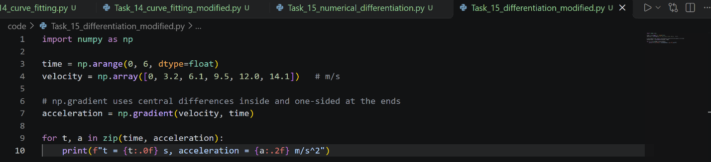
Output and interpretation: Acceleration is 3.20, 3.05, 3.15, 2.95, 2.30, 2.10 m/s². It is around 3 m/s² at the start and then falls to about 2.1 m/s², which is typical of a vehicle accelerating less as speed increases.

Task 16: Numerical Integration.
B. Inputs and operation: Smart-meter power (kW) every 2 hours over 12 h. Trapezoidal rule and Simpson's rule integrate power over time to give energy.
D. Output: Trapezoid 15.700 kWh, Simpson 15.800 kWh, difference 0.100 kWh. The household used about 15.7–15.8 kWh in 12 hours. The two rules differ slightly because Simpson fits parabolas and follows the curved shape of the data better.
C. Parameter change: Multiplying all power readings by 1.2 (power_kw = power_kw * 1.2) gives 18.84 kWh, exactly 1.2 times more, because integration is linear.
E. Modified case (distance from bus speed): Speed in m/s every 5 s for 30 s: 0, 8, 14, 16, 15, 9, 0 (the bus accelerates and then stops).
Modified program (code/Task_16_integration_modified.py):
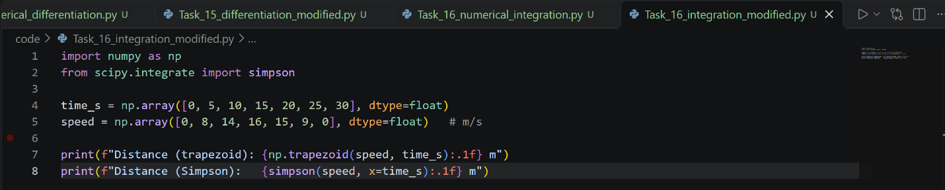
Output and interpretation: Trapezoid 310.0 m, Simpson 316.7 m. The bus travelled about 310–317 m. The difference of about 6.7 m (2%) shows that the choice of rule matters when sampling is coarse.

Task 17: Ordinary Differential Equations: Euler Method.
B. Inputs and operation: dT/dt = −k(T − 25) with T(0) = 90 °C, k = 0.12 per minute, step h = 1 min for 30 min. Euler repeats T(n+1) = T(n) + h·f(T(n)).
D. Output: Euler gives 26.40 °C after 30 min against the exact 26.78 °C, error 0.372 °C. On the graph both curves drop quickly at first and then flatten toward the room temperature of 25 °C. The Euler curve sits slightly below the exact curve.
C. Parameter change: Step size h = 0.5 gives error 0.189, h = 2.0 gives 0.717 and h = 5.0 gives 1.51. So the error is roughly proportional to h (first-order method). With k = 0.25, the object cools faster and is at 25.01 °C after 30 min.
E. Modified case (drug concentration in blood): dC/dt = −0.173·C, initial 10 mg/L, so the half-life is about 4 h.
Modified program (code/Task_17_euler_modified.py):
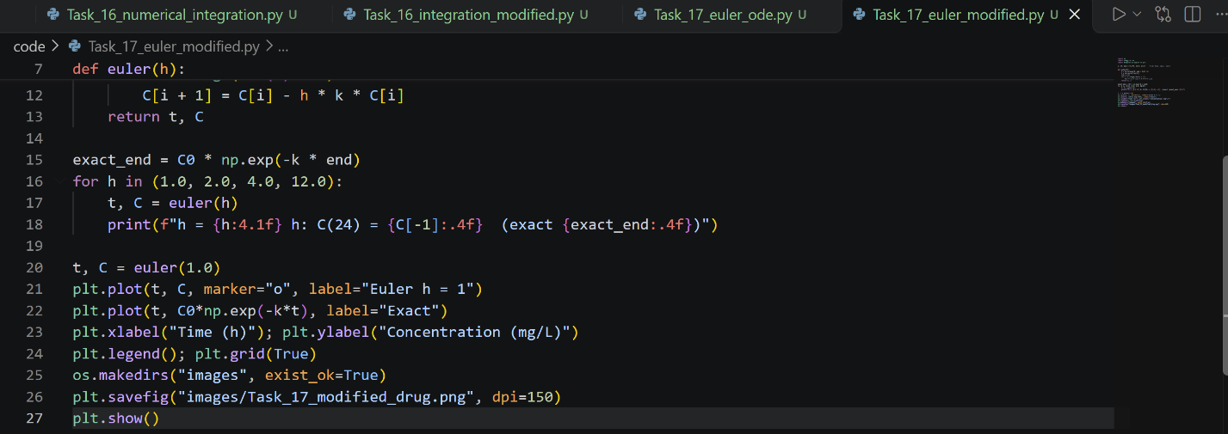
Output and interpretation: C(24) = 0.1047, 0.0612, 0.0085 and 11.5778 for the four step sizes, against the exact 0.1573. Euler underestimates the concentration. With h = 4 h the answer is badly wrong, and with h = 12 h the values oscillate and grow because h·k is greater than 2, which makes the method unstable. We must choose a small step.

Task 18: Numerical Solution of ODEs Using SciPy.
B. Inputs and operation: dV/dt = (Vs − V)/(RC) with Vs = 5 V, R = 1000 Ω, C = 0.001 F (RC = 1 s), V(0) = 0 over 0–5 s. solve_ivp uses an adaptive higher-order method with tight tolerances.
D. Output: The solver succeeds and the capacitor is at 4.9663 V at 5 s. The maximum error against the exact curve is about 9.3e-10 V, so it is much more accurate than Euler. The graph shows the voltage rising quickly and levelling off at 5 V, and the dashed exact curve lies exactly on the solver curve.
C. Parameter change: With RC = 0.5 s (for example C = 0.0005) the capacitor reaches 4.9998 V (charges faster); with RC = 2 s only 4.5896 V (charges slower). At t = RC the voltage is about 63% of 5 V, which is about 3.16 V.
E. Modified case (SIR epidemic model): S, I, R as fractions of the population; start with 1% infected; recovery rate 0.1 per day; infection rate β = 0.4 (basic reproduction number R₀ = 4); 100 days.
Modified program (code/Task_18_scipy_ode_modified.py):
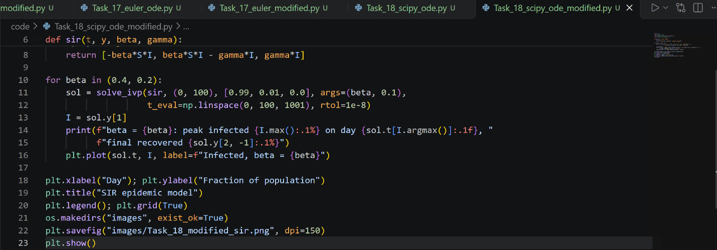
Output and interpretation: With β = 0.4 the peak is 40.6% infected on day 19.4 and 98.0% are recovered at the end (only 1.96% never infected). With β = 0.2 (R₀ = 2) the peak is 15.8% on day 43.8 and the final recovered 77.6%. Halving the contact rate (for example by distancing) lowers and delays the peak, which would reduce the pressure on hospitals.

Task 19: Numerical Optimization.
B. Inputs and operation: Cost = 12x + 18y with constraint 100x + 170y ≥ 1000 and x, y ≥ 0. minimize with SLSQP finds the lowest cost; a loop then tests whole numbers of servers.
D. Output: Continuous optimum x = 0, y = 5.882, capacity 1000, cost 105.88. The best whole-server answer is 0 Type A and 6 Type B, with capacity 1020 and cost 108. Type B costs about 0.106 per capacity unit against 0.12 for Type A, so the optimizer uses only B. The capacity constraint is exactly met, so we do not pay for extra capacity.
C. Parameter change: Changing 18*y to 10*y in cost still selects only B (y = 5.882) with cost 58.82. Raising the required capacity to 1500 gives y = 8.824 and cost 158.82, so cost grows in proportion to the requirement.
E. Modified case (fertilizer mix): Fertilizer 1 costs 30 per bag and gives 10 kg N and 5 kg P; Fertilizer 2 costs 40 per bag and gives 5 kg N and 12.5 kg P. A field needs at least 12 kg N and 10 kg P.
Modified program (code/Task_19_optimization_modified.py):
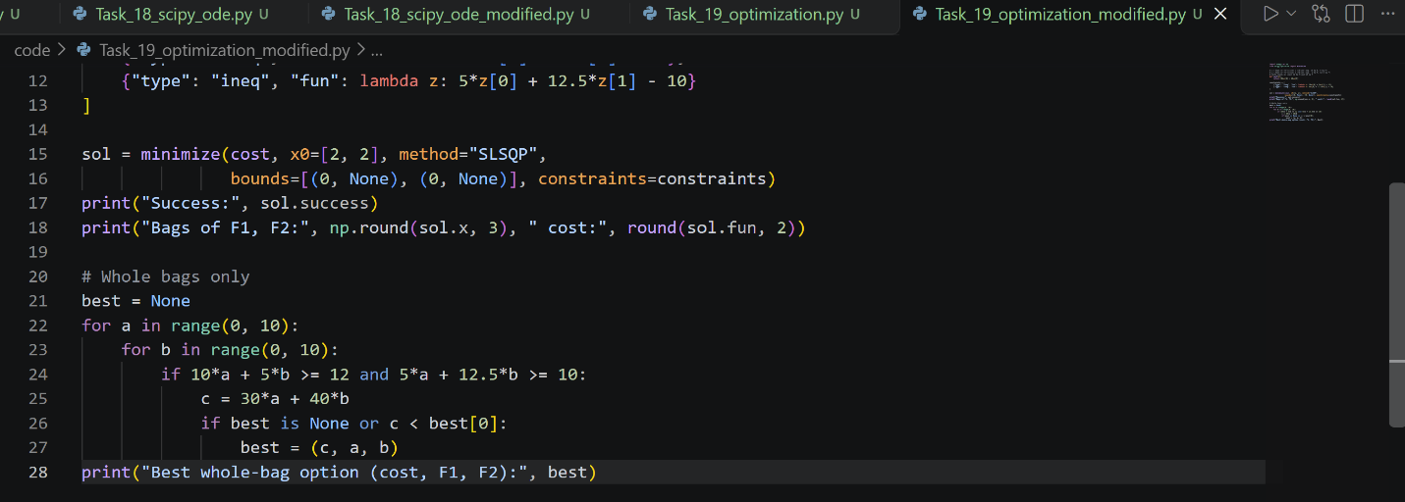
Output and interpretation: The optimum is 1.0 bag of F1 and 0.4 bag of F2 with cost 46; with whole bags only the best is (cost 60, 2 bags of F1, 0 of F2). Both nutrient constraints are exactly met at the optimum. Buying only whole bags costs 14 more than the ideal mix.

Task 20: Random Numbers and Monte Carlo Methods.
B. Inputs and operation: Server capacity 1000, demand normally distributed with mean 850 and standard deviation 120, N = 100,000 simulations (seed 42). The overload probability is the fraction of runs with demand above capacity.
D. Output: Estimated overload probability 10.616% (10,616 of 100,000 cases). The exact normal-distribution value is 10.565%, so the simulation is within 0.05%. The graph shows the running estimate swinging at small N and settling near 10.6% as N grows.
C. Parameter change: std_demand = 200.0 gives 22.60%; mean_demand = 950.0 gives 33.59%; a standard deviation of 60 gives only 0.65%. More uncertainty or more demand raises the risk. For the number of simulations: N = 100 gives 2%, N = 1,000 gives 10.1%, N = 10,000 gives 10.49% and N = 1,000,000 gives 10.57%. Estimates become more reliable as N grows.
E. Modified case (project completion time): Three tasks in sequence with triangular durations (min, most likely, max) in weeks: (4, 6, 10), (3, 5, 9), (5, 8, 14); tasks are independent; 200,000 runs.
Modified program (code/Task_20_monte_carlo_modified.py):
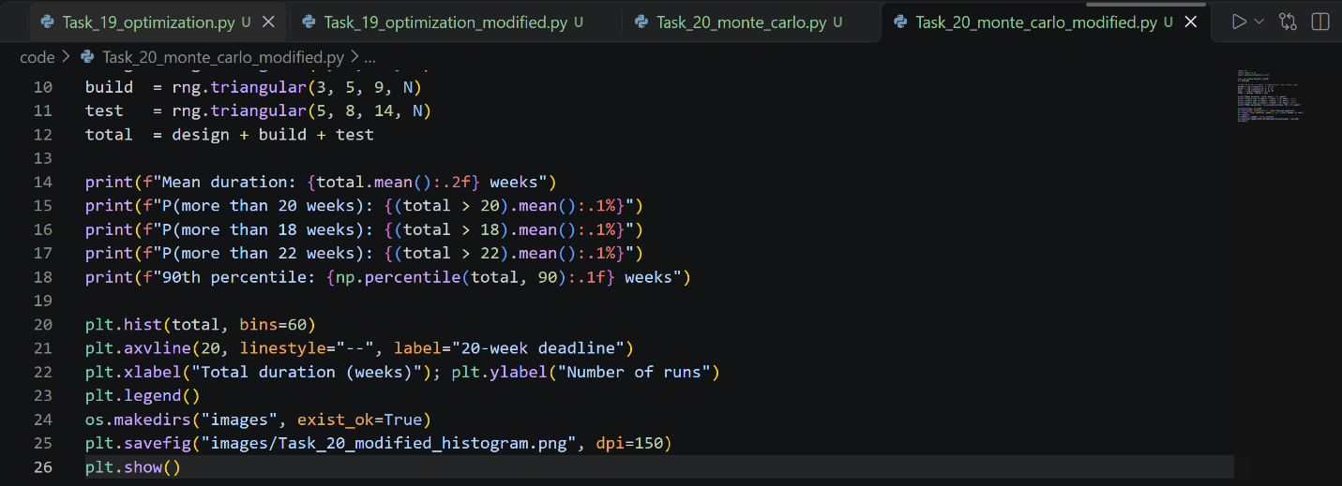
Output and interpretation: Mean duration about 21.33 weeks, a 68.1% chance of exceeding 20 weeks, and a 90th percentile of about 24.7 weeks. The 18- and 22-week probabilities come out near 90.5% and 39%; they may differ by about 0.1% from run to run because the random draws differ slightly. A 20-week deadline is more likely to be missed than met. To be 90% sure, we should plan for about 25 weeks.

